**HOSPITAL MANAGEMENT SYSTEM**

Shedikujjaman Anik (210201040), Sharifa Rahman Sweety (210201019), Tasnimuzzaman Tasin (210201015)

Course Code: CSE 2206 Course Title: Database Management systems Sessional

Semester: Winter 2023

*Department of Computer Science and Engineering, Bangladesh Army University of Science and Technology (BAUST)

**1.Introduction**

* Patient Information Management.
* Electronic Health Records (EHR).
* Telehealth Support.
* Improved Patient Care.

**2.Problem Definition**

* patient data disorganization
* appointment backlogs
* data security and privacy
* patient engagement and access
* maintenance and updates

**3.Available Applications**

There are a few websites and apps such as:

* Nih.gov[1]
* healthline.com[2]
* Soft Clinic[3]

Although these websites are meant to be for medical purposes. They don’t give all the necessary facilities.

Their main problem is that they are only made and concentrated for certain regions of the world. Some are only for research purposes which is not very helpful for non-medical personals.

**4.Stakeholders**

* patients: the primary recipients of healthcare services.
* healthcare providers: doctors, nurses, and other medical staff.
* hospital administration: the management and administrative teams responsible for day-to-day operations.
* insurance companies: entities that may cover patients' healthcare costs.
* government and regulatory bodies: responsible for healthcare regulations and compliance.
* suppliers: companies providing medical equipment, pharmaceuticals, and supplies.
* it vendors: providers of software and technology solutions.
* patients' families: often involved in decision-making and care planning.
* research institutions: collaborators for medical research and trials.
* non-governmental organizations (ngos): organizations supporting healthcare initiatives.

**5.issues encountered**

* Data Security: Safeguarding patient information.
* Interoperability: Ensuring systems can work together.
* User Training: Adequate education for staff.
* Integration Challenges: Coordinating with existing systems.
* Scalability: Adapting to hospital growth.
* Customization: Tailoring the system to unique needs.
* Budget Constraints: Managing financial limitations.
* Regulatory Compliance: Meeting healthcare regulations.
* Technical Issues: Addressing software and hardware issues.
* User Resistance: Overcoming staff reluctance.
* Vendor Reliability: Trusting external system providers.
* Patient Experience: Enhancing care and satisfaction.
* Data Accuracy: Ensuring precise information entry.

**6.System Architecture**



**7.Database Design**

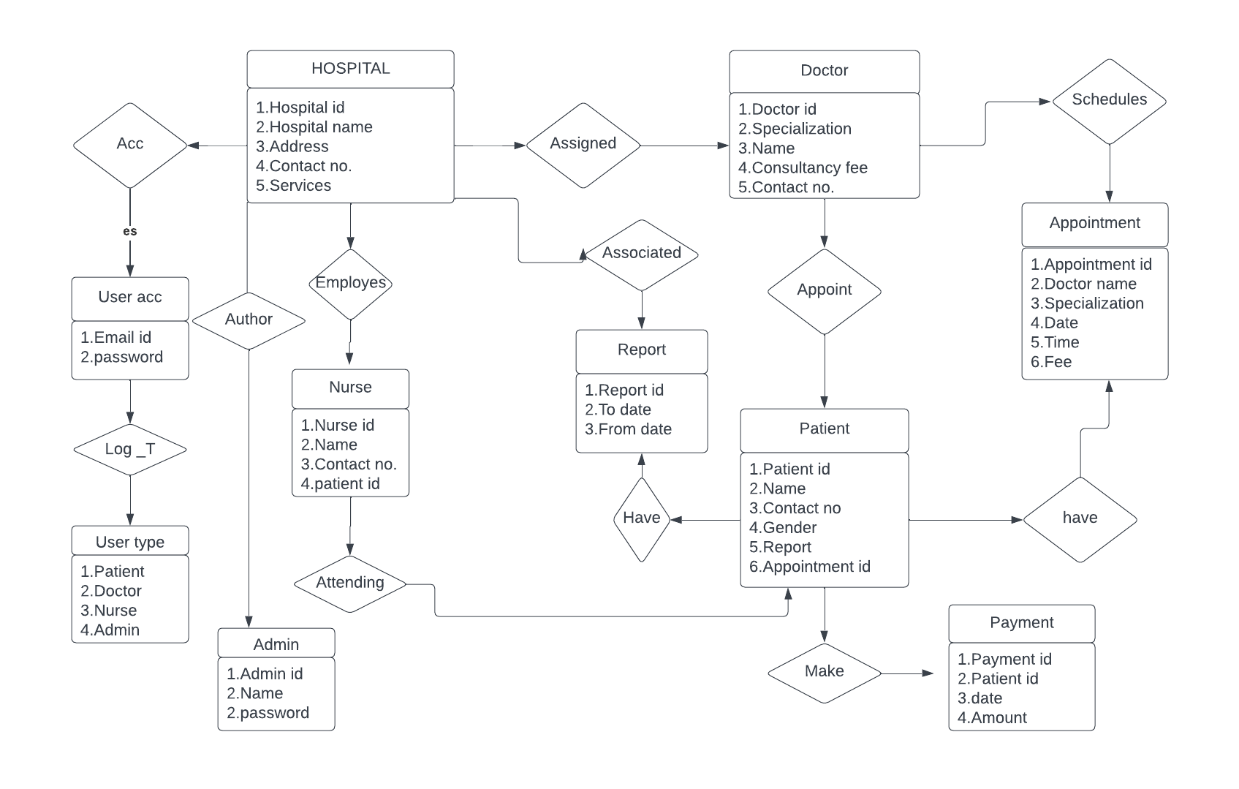

**8.Tools and Technologies**

* HTML
* CSS
* BOOTSTRAP
* MYSQL
* PHP

**9.Implementation(Homepage)**

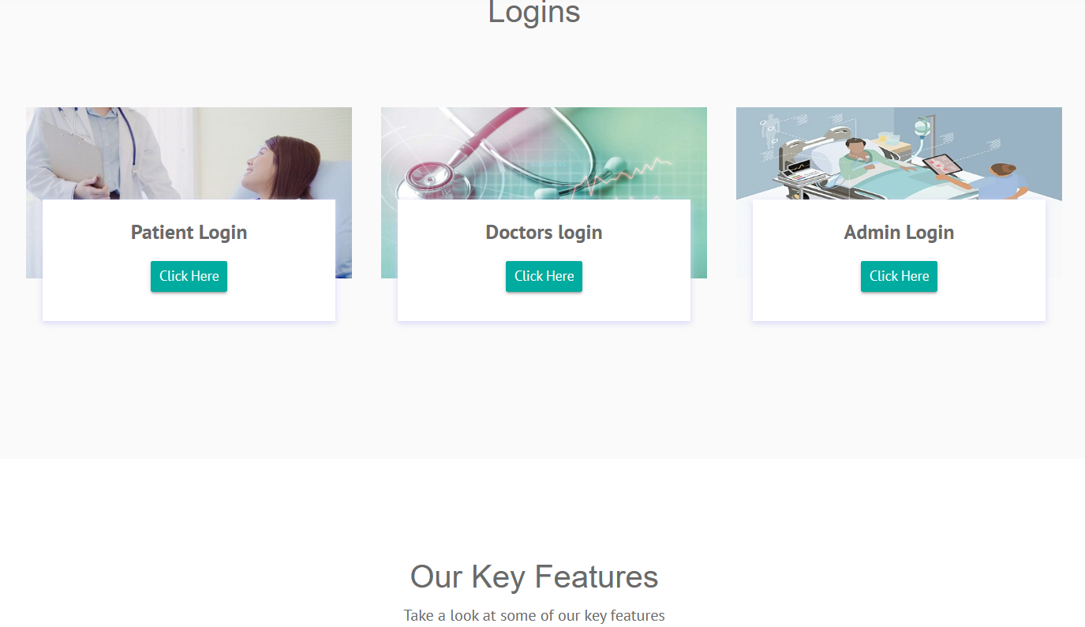

**Loginpage**

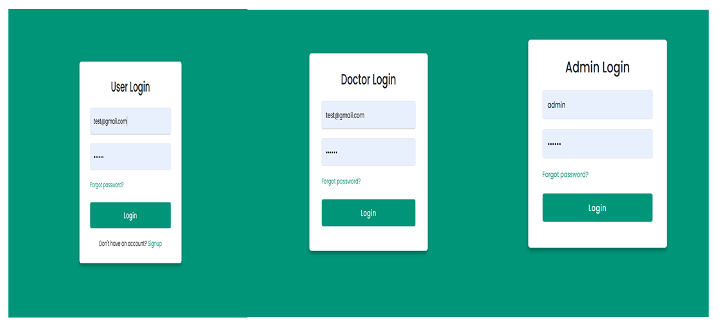

**Doctor Dashboard**

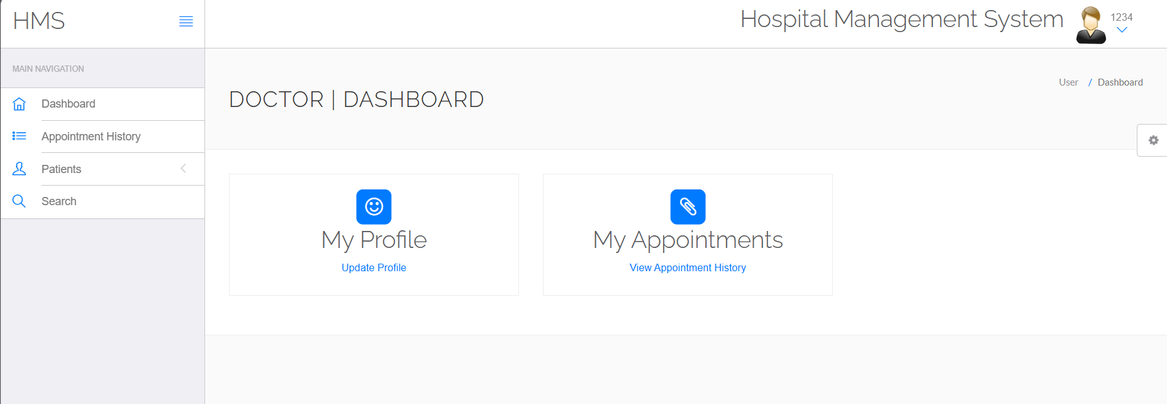

**User Dashboard**

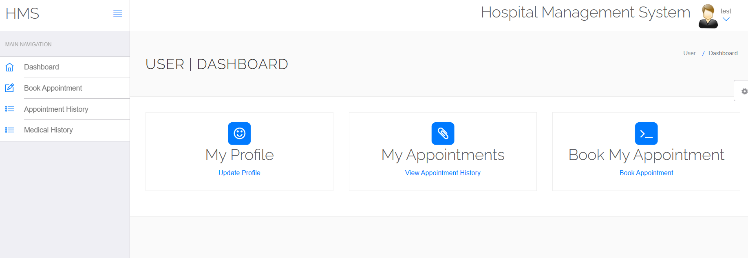

**Admin Dashboard**

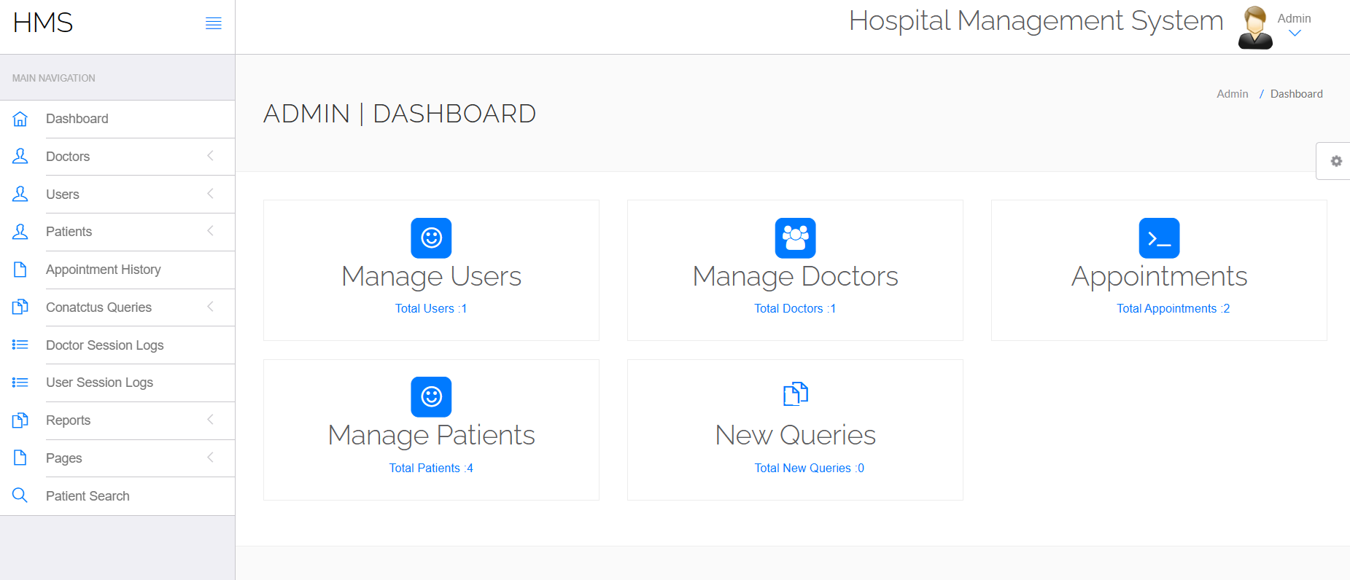

**Add Patient**

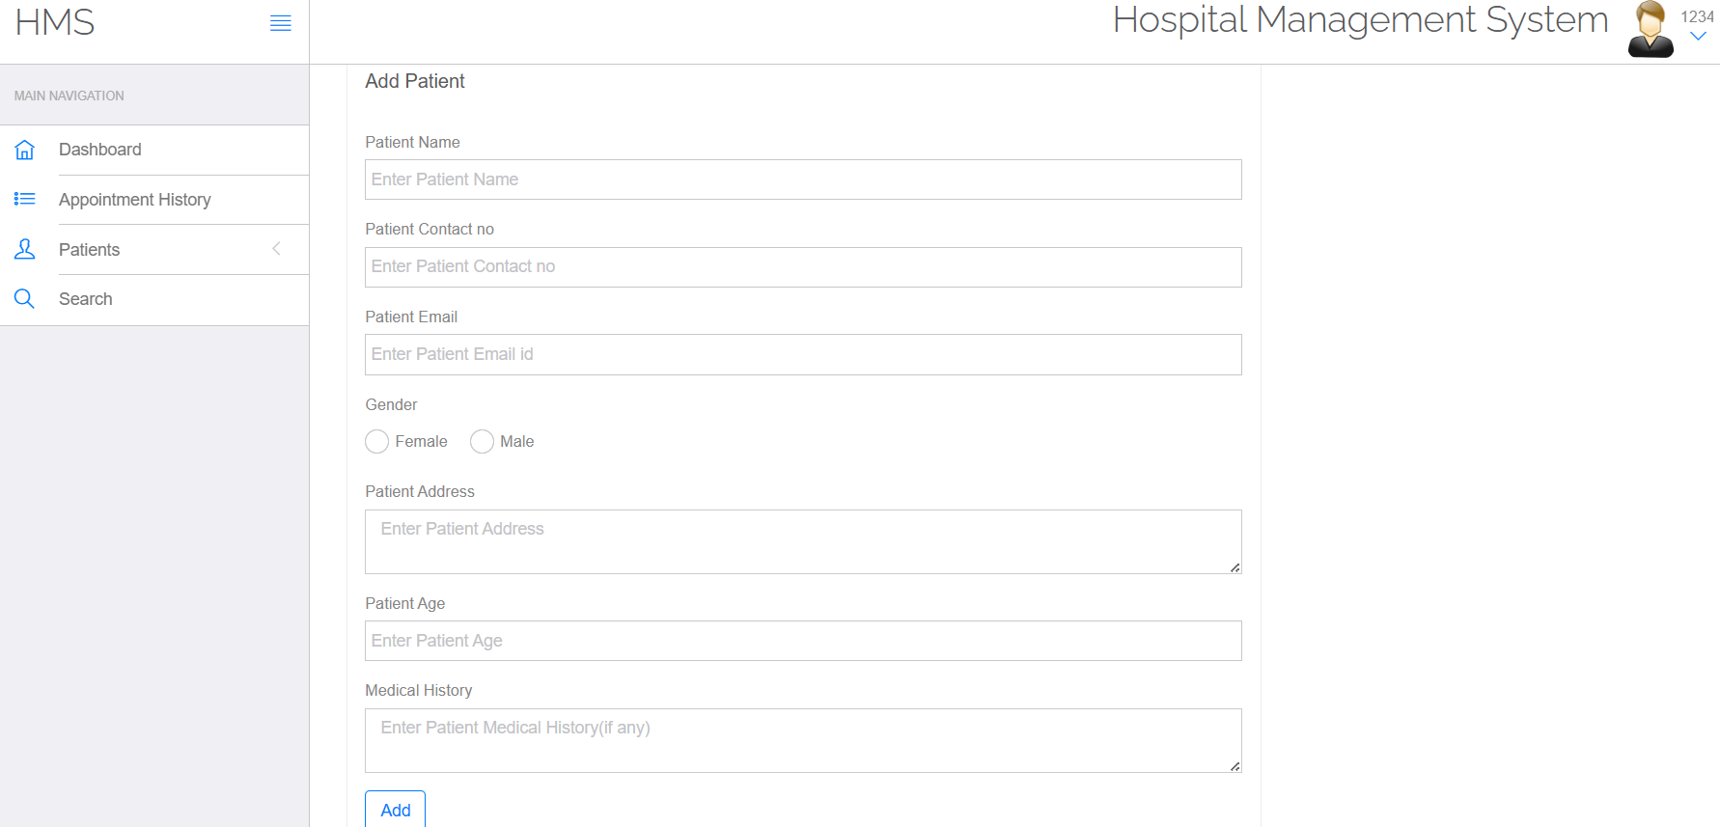

**Manage Doctors**

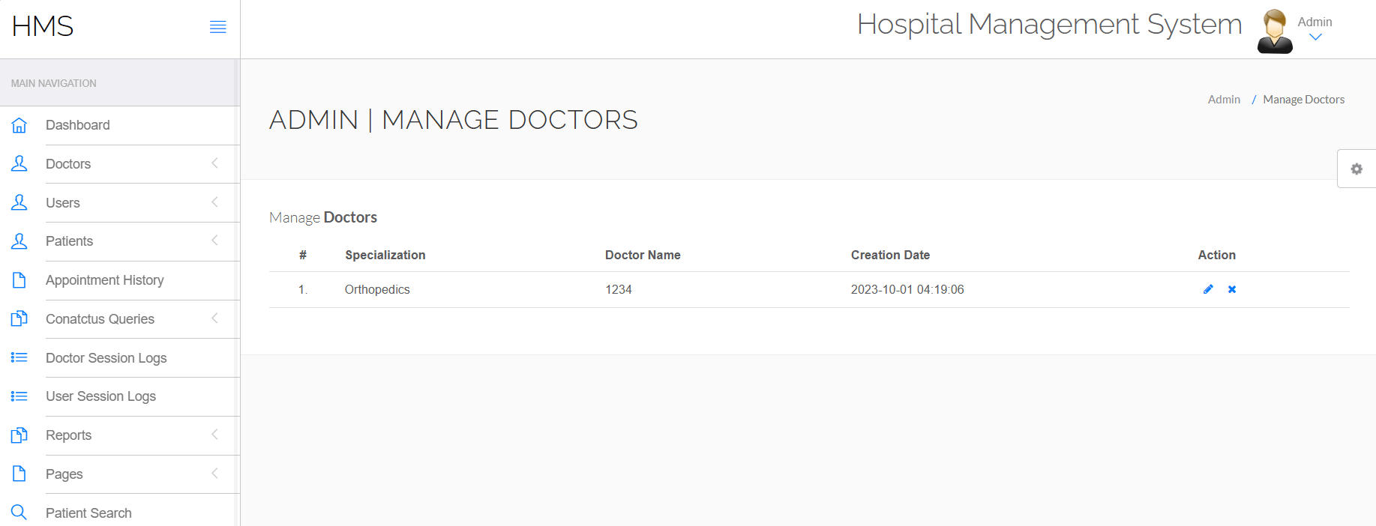

**View Patients**

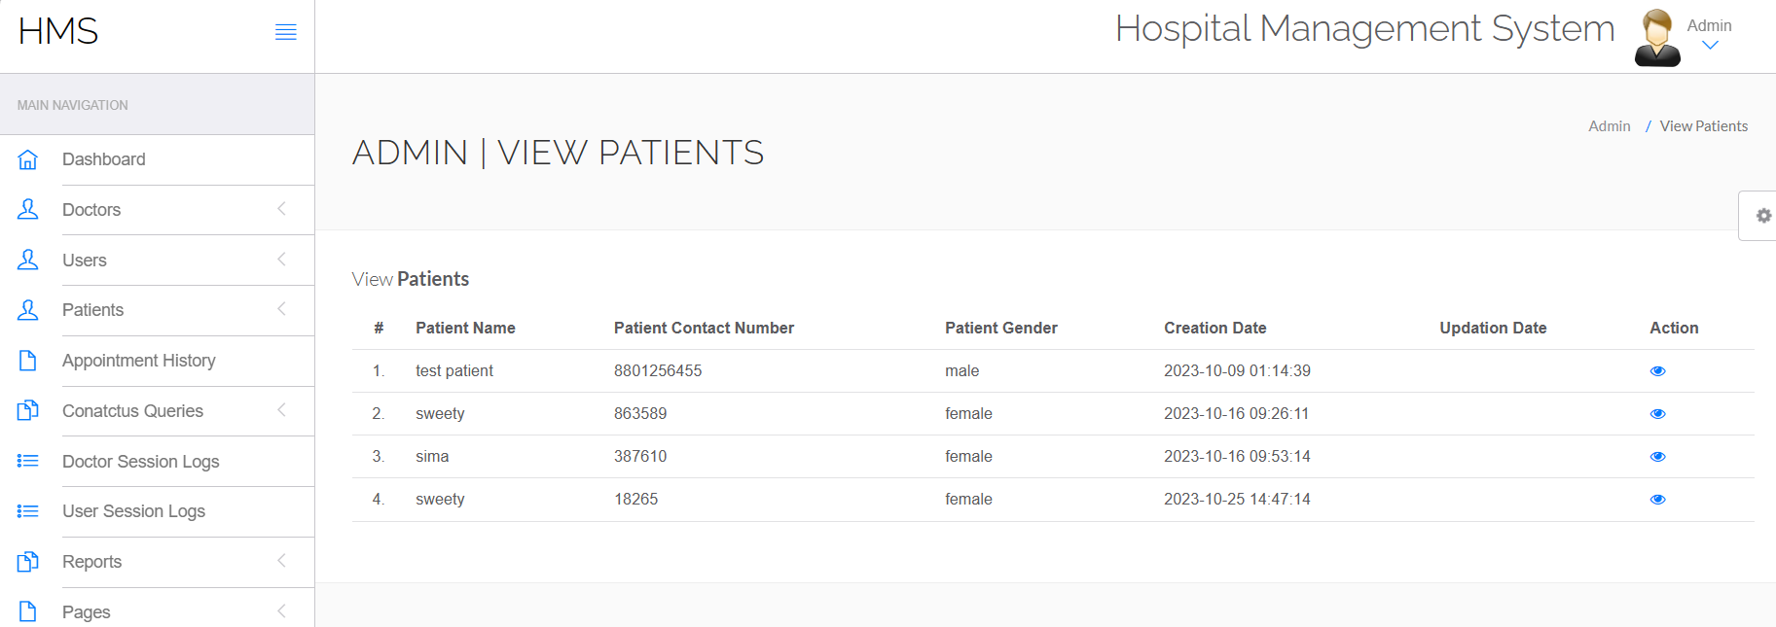

**10.Conclusion**

* A hospital management system is a vital tool for modern healthcare facilities, streamlining administrative tasks and improving overall patient care.
* It enhances efficiency by digitizing patient records, appointment scheduling, and billing processes.
* Moreover, it facilitates data management and analysis, enabling better decision-making.
* Ultimately, a well-implemented hospital management system can lead to cost savings, improved patient satisfaction, and better healthcare outcomes**.**

**Limitations**

* High Implementation Costs: Setting up and customizing a Hospital Management System can be expensive, including the costs of software, hardware, training, and ongoing maintenance.
* Complex Implementation: Implementing these systems in a healthcare facility can be a complex and time-consuming process, often requiring significant changes in workflow and staff training.
* Scalability Challenges: Adapting the system to accommodate the needs of growing or changing healthcare facilities can be a challenge.

**References**

* [**https://www.nih.gov/**](https://www.nih.gov/)
* [**https://www.healthline.com**](https://www.healthline.com/)
* [**https://www.techpout.com/hospital-management-software/#1_Soft_Clinic**](https://www.techpout.com/hospital-management-software/)

**Appendix**

Attainment of Complex Engineering Problem (CP)

|  |  |  |  |
| --- | --- | --- | --- |
| S.L. | CP No. | Attainment | Remarks |
| 1. | P1: Depth of Knowledge Required |  | K3 (Engineering Fundamentals): |
| K4 (Engineering Specialization): |
| K5 (Design): |
| K6 (Technology): |
| K8 (Research): |
| 2. | P2: Range of Conflicting Requirements |  |  |
| 3. | P3: Depth of Analysis Required |  |  |
| 4. | P4: Familiarity of Issues |  |  |
| 5. | P5: Extent of Applicable Codes |  |  |
| 6. | P6: Extent of Stakeholder Involvement and Conflicting Requirements |  |  |
| 7. | P7: Interdependence |  |  |

Mapping of Complex Engineering Activities (CA)

|  |  |  |  |
| --- | --- | --- | --- |
| S.L. | CA No. | Attainment | Remarks |
| 1. | A1: Range of resources |  |  |
| 2. | A2: Level of interaction |  |  |
| 3. | A3: Innovation |  |  |
| 4. | A4: Consequences for Society and the Environment |  |  |
| 5. | A5: Familiarity |  |  |